World Regional Geography Assignment: Name: Luke Pepin

**Population Pyramids**

Please use the following population pyramids and country descriptions to match the pyramids by placing the letter of the appropriate country description next to the pyramid that best fits that country. Provide a brief explanation of why you chose the country you chose for each pyramid, below that pyramid.

1. Cambodia – This nation experienced intense conflict during the early to mid-1970s associated with the Vietnam war and then internal genocide from 1975-1979. Since the 1990s, it has been a more stable state, but still experiences widespread poverty.
2. Democratic People’s Republic of Korea (North Korea) – North Korea has been an isolationist state with a communist/dictatorial government since the Korean War in the 1950s. Isolationist policies and international sanctions related to its nuclear program have kept the economy weak. North Korea has relatively low average life expectancy, just below 70 years, with a median age of 32.9. It has experienced, slow growth in population over the past few decades with more females than males in the overall population, largely because women are a larger portion of older population groups.
3. Japan – Following its defeat after World War II, Japan devoted much of its economy to industrial growth and became the second largest economy in the world through the 1990s and early 2000s. Japan has discouraged immigration and with greater wealth birth rates have declined and life expectancies have become greater so the population is aging.
4. Mongolia – Mongolia is a land-locked nation with relatively little contact with the outside world and a large, rural population, much of which is nomadic or semi-nomadic. Mongolia experienced a democratic revolution in 1989-90, followed by brief growth in the economy and then a period of food shortages and lower fertility rates in the late 1990s. Fertility rates recovered in the mid-2000s.
5. People’s Republic of China – China has the largest population of any nation on Earth and the government has tried to control population growth in various ways, including the “one child” per family policy that was in effect from 1979-2015. This country also has some of the largest disparities in gender (more males than females) in the world.
6. Republic of Korea (South Korea) – South Korea was led by a military government following the Korean War (until 1987) and rapidly developed into one of the largest economies in the world. As a well-developed economy, birth rates have slowed in the last decade or so, but population is still about twice that of North Korea.

Country:_South Korea Country: E. China

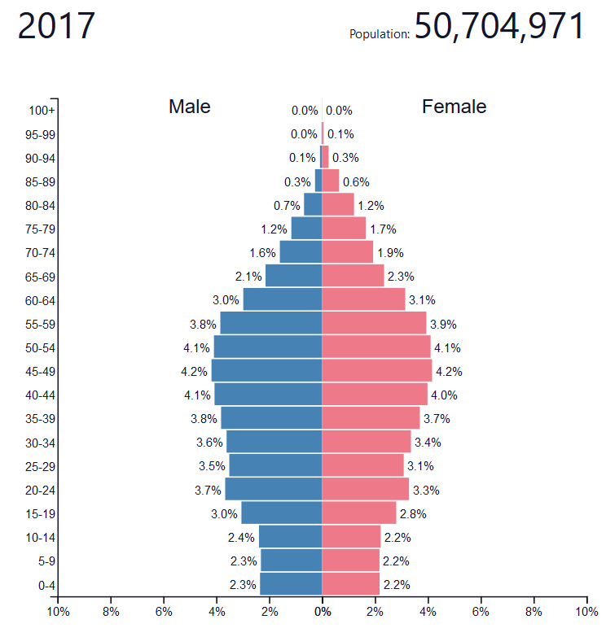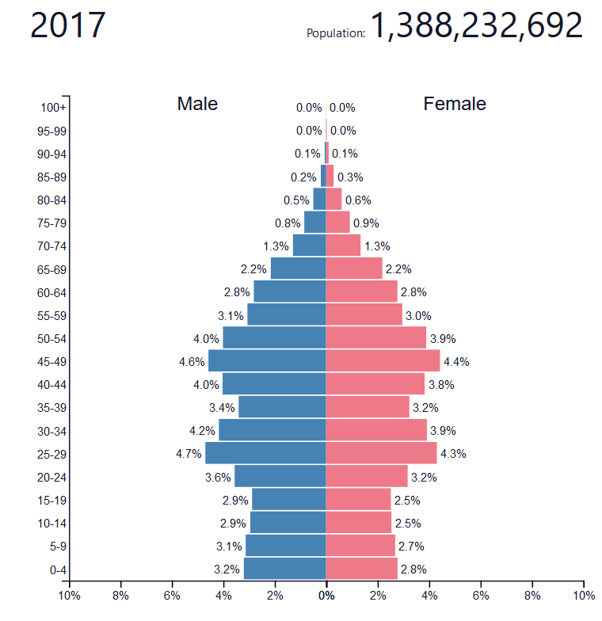

Explanation:Twice what I put as North Korea Explanation: Huge Popluation

25*2 = 50

Country: A. Cambodia Country:

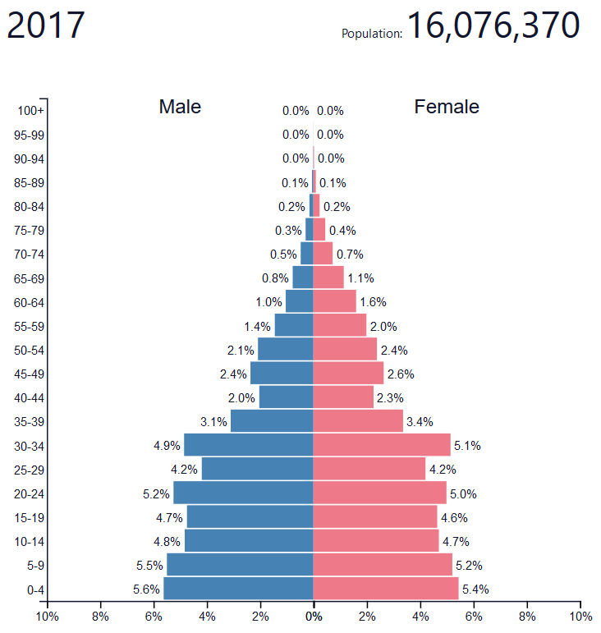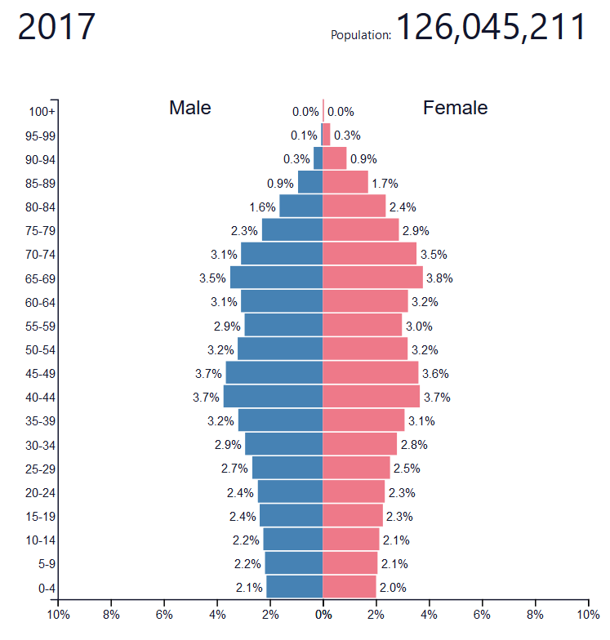

Explanation: Population growth for under 39 Explanation: aging population refects

2017-29 = 1988, not many old people japan and population matches

Country: B. North Korea Country: D. Mongolia

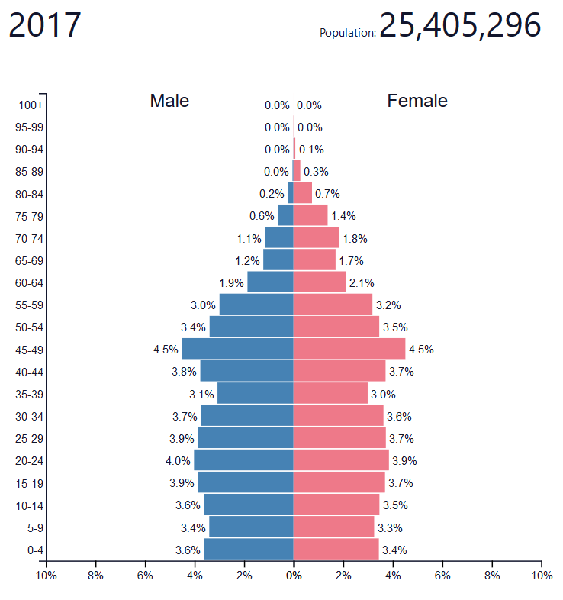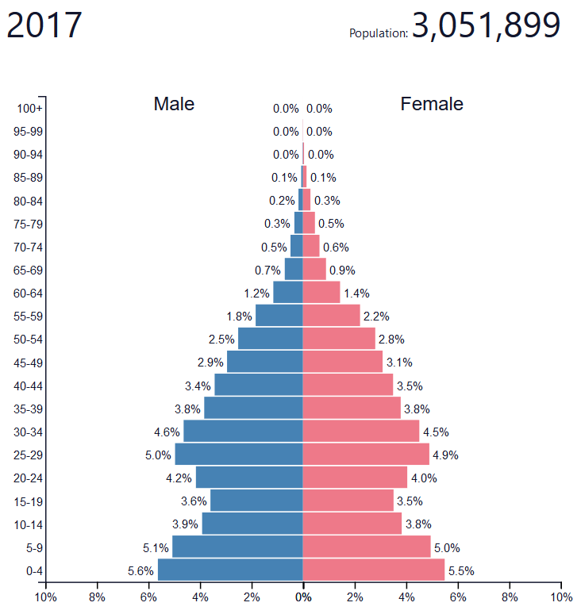

Explanation: Aging population with a Explanation: Reflects the low population and the

Very low life expectancy without much growth divot of low fertility in the 90s